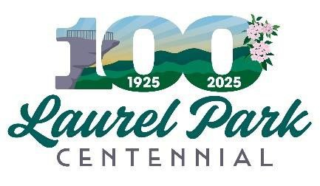

January 13, 2025, at 11:30 a.m. REGULAR MEETING AGENDA

1. **Call the meeting to order**
2. **Approval of the Agenda**
3. **Approval of December 9, 2024, Regular Meeting Minutes**
4. **Old Business**
   1. Sponsorships update
   2. Scavenger Hunt Update
   3. Challenge Coins Update
   4. Art on main Update
   5. Bear update
   6. Historical Book Update
   7. Historical Presentation Centennial Night

5. New Business

a.

6. Adjournment